**AMIRA ASSESSMENT TIPS**

-Show the amira powerpoint sent by Ms. Tortora to the whole class before.

-Have students talk right into the ipad and go as close as they can- especially for the “wake up spot” and “I’m ready to start” in the beginning.

-If students are speaking and green/red lines are not coming up try to log out of Amira and log back in- and try again.

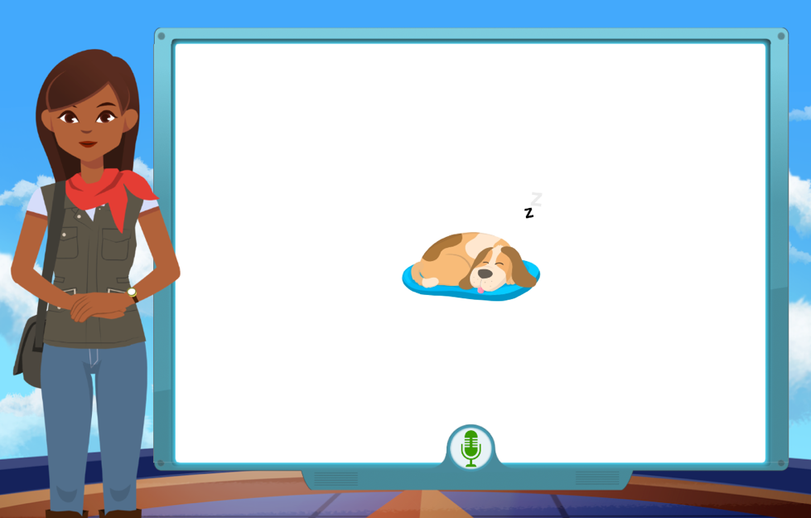

Wake up Spot!

Green lines are good- it means Amira hears them. Red lines may indicate the microphone is working but may not understand the student.

-If it cannot understand the student after a few times as the teacher you can say “wake up spot” or “I’m ready to start”. It will not impact the assessment.

After students say “wake up spot” they will be prompted to say “I am ready to begin)

This time you will see a circle spinning if it was successful.

I am ready to begin

Assessment

Read the numbers.

\

Say the sound the letter makes.

Read the word.(try, If you cannot say nothing)

Read the paragraph. (If you cannot say nothing)

Read nonsense words.(Try, if you cannot say nothing)